**A guide to the DUO template**

This is a general guide for the DUO template.

The DUO template has been created by the University to help with the writing and submission of master's theses and student papers.

To get started quickly with using the template, read [the quick start guide](http://www.ub.uio.no/english/publishing/students/templates/quick-guide.html).

**Downloading and saving the template**

* [DUO-template for Word for Windows 2010](http://www.ub.uio.no/publisere/studenter/maler/oppgavemalWord2010.docx)
* [DUO-template for Word for Windows 2007](http://www.ub.uio.no/publisere/studenter/maler/oppgavemalWord2007.docx)
* [DUO-template for Word for Mac 2011](http://www.ub.uio.no/publisere/studenter/maler/mac-duo.docx)

The above links will open the templates. Before you can start using the template, you must store it. If you use Internet Explorer as your browser, it might be difficult to open the file by clicking on the link. If you encounter problems, right-click on the link and save the file, then open the file from the saved location.

**About versions and languages**

This guide is written on the basis of Word for Windows 2010.

Word for Mac and other Word version may differ. Functions described in this guide are present in all versions. Descriptions and pictures in the guide may be slightly different than what appears on your screen. Menus might be structured differently, and you may need to proceed through a different number of steps as you follow the stated instructions. Microsoft's own pages may be helpful in determining where functions are placed in your version.

* [Microsoft Office for Windows](http://office.microsoft.com/en-us/) (microsoft.com)
* [Microsoft Office for Mac](http://www.microsoft.com/mac) (microsoft.com)

This guide is based on an English Word version. Please note that you can change the language in Word from Norwegian to English or English to Norwegian. If you have an English version of Windows and/or Word, you may find that your screen “mingles” Norwegian and English in menus and style names. This depends upon the setup of your PC and does not affect the program, the template or the style function.

**Do not use different versions of Word**

If you started typing in one Word version, you should not open and save the document in another one. If you do this, the document could be damaged or destroyed.

**Working with Styles**

Styles are specially designed sets of font, sizes and formats. Styles are stored and can be used again. It is recommended that you always use styles when working on a large document, especially when the document is required to meet formatting and typography-related requirements. Explore the various styles available in the DUO-template and use them as intended. Styles are also important for the creation of a table of contents. A table of contents is generated automatically based upon the styles of the headlines, so it is important that headings have the correct styles and proper hierarchy.

**View styles in a Word document**

When beginning your work with styles, click on the Home tab and locate the Styles group.

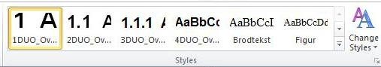

When you locate the cursor in your text and move the arrow to a style in the Quick Style gallery, the text will change temporarily, previewing how the text will look. To choose a style, click on the style in the gallery. To apply a style to a block of text, highlight the text and click the style in the Quick Style gallery.

If you are curious about the style of a specific block of text, click on the text and refer to the Quick Styles gallery. The style of the text will be highlighted.

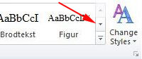

If you wish to see more styles than are displayed in the Quick Style gallery, click the arrow button to the right of the Styles group. An additional row of styles will appear.

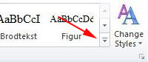

To access styles from the Styles task pane, click on ‘More’ to the right of the Styles group and choose ‘Apply Styles’. The Styles task pane will be displayed. Select the style you prefer from the menu.

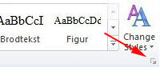

To view all available styles, click the button at the bottom right of the Styles group. The Styles window will be visible. If some styles are missing, you can expand the window by dragging on the lower right corner.

**Styles in the DUO template**

| **Name of the style** | **Information about the style** |
| --- | --- |
| **1Duo_Overskrift** | Use for chapter headlines. Automatically numbered. Included in the table of contents. |
| **2Duo_Overskrift** | Headline level 2. Automatically numbered. Included in the table of contents. |
| **3Duo_Overskrift** | Headline level 3. Automatically numbered. Included in the table of contents. |
| **4Duo_Overskrift** | Headline level 4. Not numbered. Not included in table of contents. |
| **Brodtekst** | Use for plain text. Use for all text not using any other style. |
| **Figur** | Use for naming figures, tables, pictures, graphs etc. Included in the table of figures. |
| **Sitat** | Use for quotes as well as for indented and italicized text. |
| **Uten nr. Duo** | Use for headlines previous to chapter 1. Not numbered and will not be included in the table of contents. |
| **Uten nr, etter kap.1** | Use for headlines after chapter 1 which are not to be numbered. Not numbered but included in the table of contents. |
| **Normal** | **Not to be used**. Use the style Brodtekst for all text not using an other style. |
| **Forside-stiler** | In addition to these styles, there are three styles for use only on the front page. |

**Tips and advice before you start**

**On word processing**

* Do not use the style Normal for plain text. Use the style Brodtekst.
* Press Enter when you wish to create a new paragraph or a new item on a list.
* Do not use Enter for line breaks.
* Do not use the Space key to insert extra spaces.
* This key is used only to distinguish individual words from one another. If you wish to write text in columns, create a table.
* Do not use tabs. The tabs might disappear when you convert to another format.
* Do not use the Enter key multiple times to arrive at a new page.
* Create page breaks correctly by pressing Ctrl and Enter at the same time or by pressing the button for a Blank Page in the Insert tab.
* If you wish to use "see"-references to specific pages in your paper, you must add them as cross-references and update these cross-references before you complete the document. Page numbering changes continuously during the writing of a document, so if you type in a reference to a page number early on, it will very likely be wrong later. Adding cross-references is a feature in Word.

**Formatting columns using tables**

If you wish to present data in columns, use tables. Tables are easily created in Word, and they convert nicely to other formats such as HTML and PDF. Do not use the Space key to fit text into a table. The extra space could disappear during conversions to other formats, and you might also encounter problems with the format of the table in Word if you make major changes to the text. You might also think of creating a table with invisible borders; this makes the text look more elegant. You can find options for tables by using the Insert tab.

**Document properties**

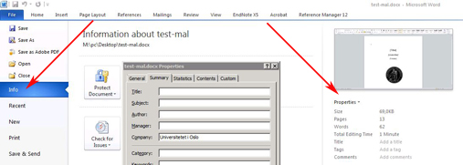

A Word document contains "invisible information". You can reveal this hidden information by clicking on  
'File' > 'Info' > 'Properties' > 'Advanced Properties'.

Enter correct author information. Default is the creator of the template.

Enter the appropriate information in the form. This information will follow the file when converted to PDF. In an Internet search, this information will be used by the search engine (e.g. Google and DUO). It is therefore important that you appear as the author of the document. At the very least, you should fill out the three following fields: title, author and organization (University of Oslo). You can also fill out the other fields if you wish.

**Starting to write**

Skip the title page, table of contents and any other parts that are automatically generated. Begin by writing the heading for the first chapter you wish to work on. This could very well be chapter 2.

**Chapter headlines.**

Locate the correct place in the document and start typing. Sample text for the chapter headings in your document has been formatted with the style '1DUO_Overskrift'.

When you replace the sample text with your own text, you might notice that '1DUO_Overskrift' is highlighted in the Quick Style gallery. The headline is now correctly formatted and will be included in the table of contents. You will find more information on how to generate a table of contents later in this document.

* All chapter headings should use the style '1DUO_Overskrift'.
* Numbering of chapter headings and sub-headings is automatically generated, so do not type numbers yourself.
* It is common to structure chapters in several levels according to the logical structure of the content. Be consistent in the use of heading levels - '1DUO_Overskrift', '2DUO_Overskrift' and '3DUO_Overskrift'.
* Remember that the styles form the basis for the automatically generated table of contents.

**The order of the chapters**

* You can begin by working on any chapter or any part of a chapter you choose. You may well begin with Chapter 2. As long as this chapter is the only chapter you are working on, it will be numbered ‘1’. This will change when you add chapters.
* When starting a new chapter, locate the cursor in front of the heading for an existing chapter and select the style '1DUO_Overskrift'. Write the heading for the new chapter; chapter numbering will be updated automatically. What was originally Chapter 1 will become Chapter 2.
* By using the Quick Style gallery, you can easily switch between the styles you need.

**Plain text, use Brodtekst**

The style 'Brodtekst' (Body) is used for plain text. Do not use 'Normal', even if you find this among the style choices.

**Paragraphs and changing styles**

To change back to 'Brodtekst' after using the style '1DUO_Overskrift', place your cursor at the end of the text of your heading and press Enter. The style will change automatically to 'Brodtekst'.

Ensure that all of your text appears in the correct style. In the illustration below, you can see different examples of headlines, plain text and figure titles. When you write plain text, use the style 'Brodtekst' and press the Enter key when you start a new paragraph. If you wish to write something other than a new paragraph, press the Enter key and select a different style from the Quick Style gallery.

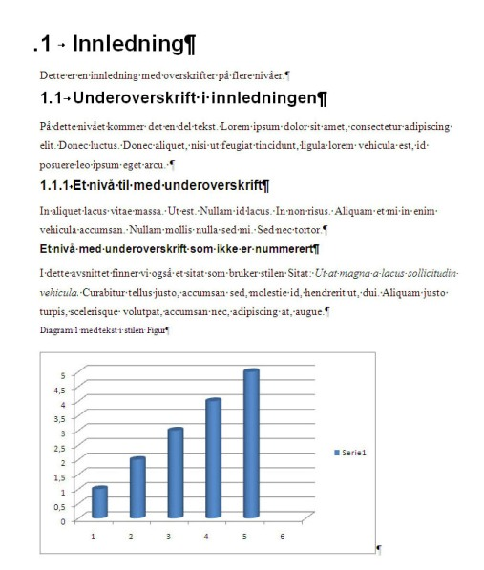

**Using elements (images, figures, etc.) from other documents or applications**

You can use text from other documents in your paper, as well as different types of images, charts and illustrations. If you are unsure about how to do this, read the [instructions for using elements from other documents or applications](http://www.ub.uio.no/english/publishing/students/templates/other-elements.html).

**Completing the document**

**Cover, title page etc.**

Title, subtitle etc. should be placed on the cover and title pages. These fields have been formatted into your document. Enter the text, using the style 'Uten nr. duo' and possibly the styles '4DUO_Overskrift' and 'Brodtekst'.

**Preface, summary, copyright information, dedication etc.**

After you complete the front and title page, type the text that will appear before the table of contents. A number of dedicated pages exist here in the template. If such a page is missing, e.g. for a dedication, type it in the headline style 'Uten nr. duo' and the style 'Brodtekst' for the text/body.

**Bibliography, EndNote and Reference Manager**

EndNote and Reference Manager are two of the most commonly used programs for keeping track of references. The University of Oslo has a site license for these programs, and all employees and students are free to install them. If you use one of these programs from the beginning of the writing process, you will save time later when you complete the reference list. If EndNote or Reference Manager is installed on the same computer as Word, tabs will appear in Word. If you have questions regarding EndNote or Reference Manager, you can  [contact the Student IT](http://www.uio.no/english/services/it/contact/student-it.html) or your library.

In EndNote and RefMan, the reference list appears at the back of the document. This presents a problem, because Vedlegg (appendixes) is the last headline in the template, and the list from EndNote and Reference Manager appears under this headline.

How can you solve this problem?

* Move the reference list to the right place by using 'cut & paste' or 'drag & drop'.
* Before moving the list, make sure that 'Instant formatting' is turned on.
  + Select the EndNote tab / Reference Manager 12 tab, then the Bibliography group and click on the arrow at the bottom corner. Select the Instant Formatting tab and see if it is enabled. It should be.
  + For Reference Manager 11, you should go to the RefMan toolbar in Word and select the 4th icon from the left, 'Instant formatting'; check to see that it is enabled.
* Move the list. It is very important to save the document immediately after you move the list. Otherwise two lists will exist the next time you go to get references from EndNote/RefMan.

If your document does not include attachments, simply remove the last page called Vedlegg (Appendix). The reference list from EndNote and RefMan will appear at the back of your document.

You can, of course, write and maintain your reference list manually, but this can be challenging.

**Create a table of contents/index**

A table of contents is generated automatically based on the styles used in the headlines. It is therefore important that the headings in the document have the correct styles and proper hierarchy.

You can create and update the index at any time during the writing process. When creating the table of contents, go to the place in your document where it says 'Table of Contents'. This where the table of contents appears. Note that if you type the title of figures with the style 'Figure', an automatically generated table of figures appears at the bottom of the index.

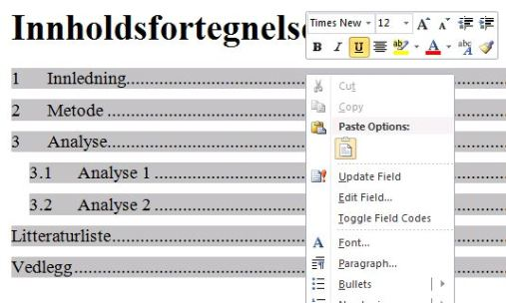

Right click on the sample text in the index and choose 'Update Field'.

If you make changes to the document later, be sure to update the index.

**Check list**

One of the last steps before finishing your paper is to update the index. Before generating the index for the last time, make sure that:

* It is all there - summary, appendix, reference list, etc.
* Tables, charts, photos are correctly positioned in the document.
* You have used the right styles and there are no additional lines or ”mingled” styles, etc.
* Line and page breaks are where you want them to be. Use Ctrl+Enter to insert page breaks if necessary.
* Check the document layout in full screen mode. To do this, go to View tab and click on the ‘Full Screen Reading’ icon.

Before you convert to PDF, make sure that:

* The information in the file properties is correct. Title, author, organization, for example.
* The lay out of each page is correct. Make sure that all your images and figures are there.
* Make sure the index is correct.

[Read about how to make a PDF from a document at USIT](https://www.uio.no/english/services/it/web/open-document-formats/pdf/index.html)

**Printing and submission**

You should allow four working days for your document to be printed at the Reprosentralen. More information regarding the submission of a thesis is available from your department.